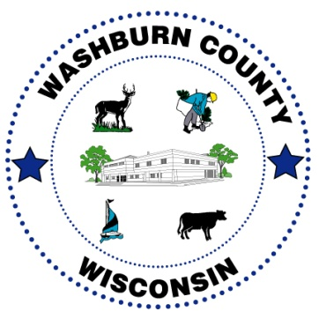
W A S H B U R N C O U N T Y

Unit on Aging

FOR IMMEDIATE RELEASE: October 6, 2020
Contact information: Washburn County Unit on Aging 715-635-4460
WHAT:
Washburn County Farmers to Families FREE Food Box Distribution

WHEN:
Wednesdays, October 21st and October 28th from 10:00 a.m. to 2:00 p.m. or until the food is gone.

WHERE:
Washburn County Highway Department, 1600 County H, Spooner, WI

NO requirements to participate.

Only ONE food box distribution per family.

As part of the Coronavirus Food Assistance Program, Secretary Perdue announced on April 17, 2020, that the USDA exercised authority under the Families First Coronavirus Response Act to purchase and distribute agricultural products to those in need. The USDA partnered with national, regional, and local distributors, whose workforces have been significantly impacted by the closure of restaurants, hotels, and other foodservice businesses, to purchase fresh produce, dairy, and meat products from American producers of all sizes. Distributors have packaged these products into family-sized boxes and transported them to food banks, community and faith-based organizations, and other non-profits serving Americans in need.

As of October 5, 2020, 101.7 Million Food Boxes have been invoiced through three phases of distribution - 35.6 million food boxes invoiced in round one (May 15-June 30), 50 million food boxes invoiced in round two (July 1-August 31) with 15 million food boxes invoiced in round two extensions (September 1 - September 18), and 1,018,464 food boxes invoiced in BOA Contracts (September 22 - October 31).

One of these contracts was awarded to Perfect Pact, who will deliver a specific number of boxes for the USDA Farms to Families for Phase III in 6 states: Florida, Illinois, Iowa, Kentucky, Minnesota, Mississippi, Missouri, North Carolina, North Dakota, South Carolina, South Dakota, Washington, and Wisconsin. As of September 1, 2020, Perfect Pact has distributed over 2,000,000 boxes of produce (42,000,000 pounds) to feed those impacted by the economic hardships of COVID-19.

Washburn County Aging reached out to Perfect Pact to discuss the program. CEO, Ted Copeland, explained the process and offered Washburn County to take part of this great opportunity. In partnership with several local organizations, Washburn County will hold two FREE food box distributions on Wednesday, October 21, 2020, and Wednesday, October 28, 2020, at the Washburn County Highway Department which is located at 1600 County Highway H, Spooner, WI. Each day 1200, twenty-two-pound boxes of food will be given out. Each box will include 5-6 pounds of produce such as apples, potatoes, onions or carrots, two dairy items like cheese, yogurt, or butter, and two pre-cooked proteins for example pulled pork and chicken. Along with the box, each family will get one gallon of milk with a total box value of approximately $55.

How will distribution work? Each day distribution will take place starting at 10:00 a.m. after the food has been delivered and unloaded at the Washburn County Highway Department. There will be one entrance and one exit to the facility. Please follow the signage and flaggers, who will be directing vehicle traffic to form two lanes and proceed to the distribution sites. You will be asked to remain in your vehicles at all times, to allow for a safe and efficient process. Once at the loading zone, you will be asked to pop your trunk. A volunteer will then put your food box and gallon of milk inside and shut the trunk. For your safety and that of our volunteers, we will all be wearing safety vests, masks, and gloves. We would ask that if at any time you need to roll down your window to speak to a volunteer, that you also please wear a mask.

Please share this information with your family and friends!

